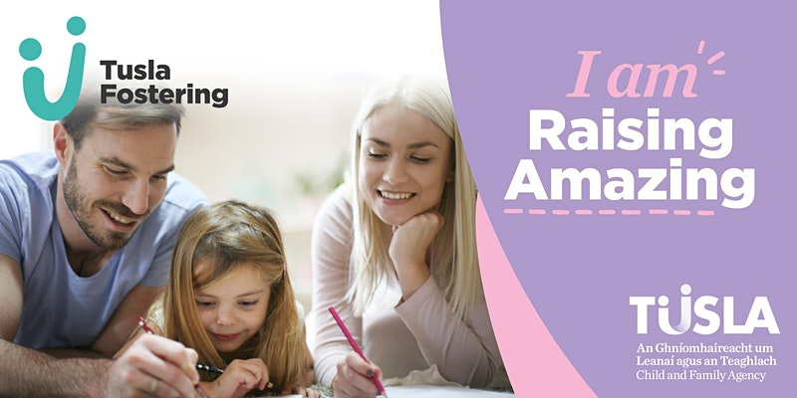
Tusla Fostering Online Information Session-Carlow, Kilkenny, Sth Tipperary
Join us for our online fostering information session and connect with experienced foster carers through this interactive event

About this event
Have you ever thought of becoming of foster carer, but you're not sure if it is right for you or your family? Maybe you have been thinking about fostering, and would like to know more about it.

Come and join us our Virtual Fostering events and we will explore with you:

- What is Foster Care?
- What do I need to Foster?
- Listen to experienced foster carers talk about their journey in fostering

We understand the decision to become a foster carer is a big one and we are here for you to guide you through and to ensure that fostering is right for you and your family. This workshop will ‘myth-bust’ around what is required to foster, including what happens during Assessments and Training - and how your skills can be developed to help you if you decide to foster.

We will also talk with experienced foster carers about what it's like to foster and you will have a unique opportunity to connect with these foster carers through this interactive event.

Follow the Link below to register for this event:
https://www.eventbrite.ie/o/tusla-fostering-32600270585
Look Forward to seeing you at this event!

